Elton, Gruber, Brown, and Goetzmann
Modern Portfolio Theory and Investment Analysis, 9th Edition
Solutions to Text Problems: Chapter 6

Chapter 6: Problem 1

The simultaneous equations necessary to solve this problem are:

5 = 16Z₁ + 20Z₂ + 40Z₃

7 = 20Z₁ + 100Z₂ + 70Z₃

13 = 40Z₁ + 70Z₂ + 196Z₃

The solution to the above set of equations is:

Z₁ = 0.292831

Z₂ = 0.009118

Z₃ = 0.003309

This results in the following set of weights for the optimum (tangent) portfolio:

X₁ = .95929 (95.929%)

X₂ = .02987 (2.987%)

X₃ = .01084 (1.084%

The optimum portfolio has a mean return of 10.146% and a standard deviation of 4.106%.

Chapter 6: Problem 2

The simultaneous equations necessary to solve this problem are:

11 − R_{F} = 4Z₁ + 10Z₂ + 4Z₃

14 − R_{F} = 10Z₁ + 36Z₂ + 30Z₃

17 − R_{F} = 4Z₁ + 30Z₂ + 81Z₃

The optimum portfolio solutions using Lintner short sales and the given values for R_{F} are:

 | R_{F} = 6% | R_{F} = 8% | R_{F} = 10%
Z₁ | 3.510067 | 1.852348 | 0.194631
Z₂ | −1.043624 | −0.526845 | −0.010070
Z₃ | 0.348993 | 0.214765 | 0.080537
X₁ | 0.715950 | 0.714100 | 0.682350
X₂ | −0.212870 | −0.203100 | −0.035290
X₃ | 0.711800 | 0.082790 | 0.282350
Tangent (Optimum) Portfolio  Mean Return | 6.105% | 6.419% | 11.812%
Tangent (Optimum) Portfolio  Standard Deviation | 0.737% | 0.802% | 2.971%

Chapter 6: Problem 3

Since short sales are not allowed, this problem must be solved as a quadratic programming problem. The formulation of the problem is:

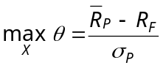

subject to:

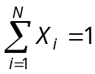

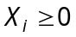 ∀ i

Chapter 6: Problem 4

This problem is most easily solved using The Investment Portfolio software that comes with the text, but, since all pairs of assets are assumed to have the same correlation coefficient of 0.5, the problem can also be solved manually using the constant correlation form of the Elton, Gruber and Padberg “Simple Techniques” described in a later chapter.

To use the software, open up the Markowitz module, select “file” then “new” then “group constant correlation” to open up a constant correlation table. Enter the input data into the appropriate cells by first double clicking on the cell to make it active. Once the input data have been entered, click on “optimizer” and then “run optimizer” (or simply click on the optimizer icon). At that point, you can either select “full Markowitz” or “simple method.”

If you select “full Markowitz,” you then select “short sales allowed/riskless lending and borrowing” and then enter 4 for both the lending and borrowing rate and click “OK.” A graph of the efficient frontier then appears. You may then hit the “Tab” key to jump to the tangent portfolio, then click on “optimizer” and then “show portfolio” (or simply click on the “show portfolio” icon) to view and print the composition (investment weights), mean return and standard deviation of the tangent (optimum) portfolio.

If instead you select “simple method,” you then select “short sales allowed with riskless asset” and enter 4 for the riskless rate and click “OK.” A table showing the investment weights of the tangent portfolio then appears.

Regardless of the method used, the resulting investment weights for the optimum portfolio are as follows:

Asset i | X_{i}
1 | −5.999%
2 | −17.966%
3 | 21.676%
4 | 0.478%
5 | −29.585%
6 | 12.693%
7 | −59.170%
8 | −14.793%
9 | 3.442%
10 | 189.224%

Given the above weights, the optimum (tangent) portfolio has a mean return of 18.907% and a standard deviation of 3.297%. The efficient frontier is a positively sloped straight line starting at the riskless rate of 4% and extending through the tangent portfolio (T) and out to infinity:
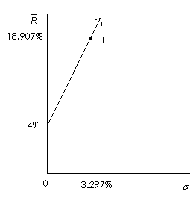

Chapter 6: Problem 5

Since the given portfolios, A and B, are on the efficient frontier, the GMV portfolio can be obtained by finding the minimum-risk combination of the two portfolios:

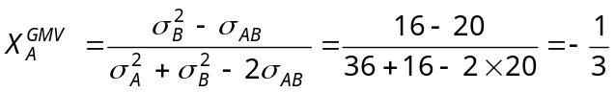

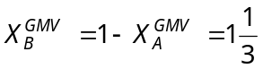

This gives 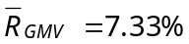 and 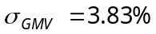

Also, since the two portfolios are on the efficient frontier, the entire efficient frontier can then be traced by using various combinations of the two portfolios, starting with the GMV portfolio and moving up along the efficient frontier (increasing the weight in portfolio A and decreasing the weight in portfolio B). Since X_{B} = 1 − X_{A} the efficient frontier equations are:

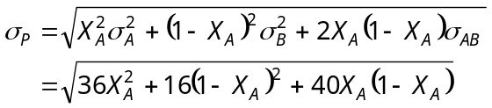

Since short sales are allowed, the efficient frontier will extend beyond portfolio A and out toward infinity. The efficient frontier appears as follows:

